|  |  |  |
| --- | --- | --- |
| **LAB 321Assignment** | **Type:** | **LongAssignment** |
| **Code:** | **J3.L.P0025** |
| **LOC:** | **500** |
| **Slot(s):** | **15** |

**Title:** CC Computer Courses

**Background**

### You want to develop a online training courseware?

Complete this assignment to know how to to it ☺

Reference site:<http://us-123-education.simplesite.com/>

**Program Specifications**

Program a simpleonline training courseware, detail functions of this website is described below

**Features:**

This website contains 3 main functions

* Function 1 : Home page : ( see PIC 01)
  + Display introduction entry and short description of all course with ( date )
* Function 2 : Course ( PIC 02)
  + Display all courses sort by published date
* Function 3 : Contact ( PIC 03)
  + Help user to submit her requests

You do not need to write interface for admin control panel, you can add data manually (use SQL SERVER Management studio).

Note: All data must be load from database, not hard code in page.

***Expectation of User interface:***

Pic 01 : Home Page

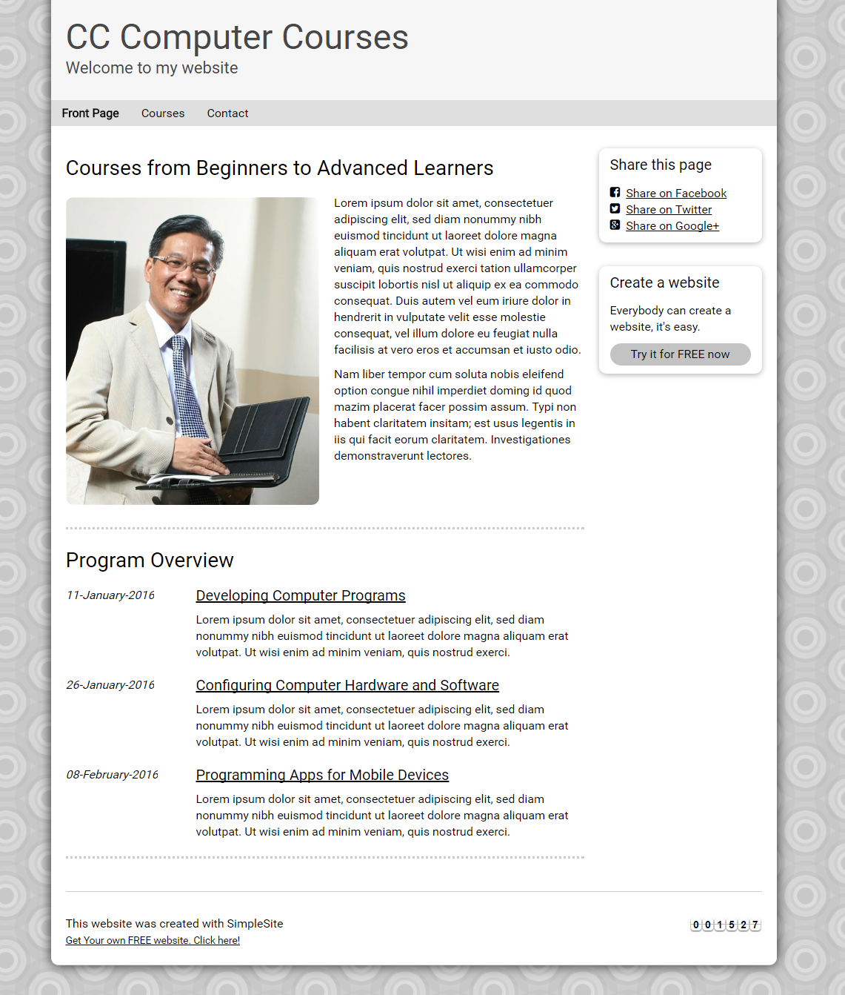

PIC 02 : Display all course

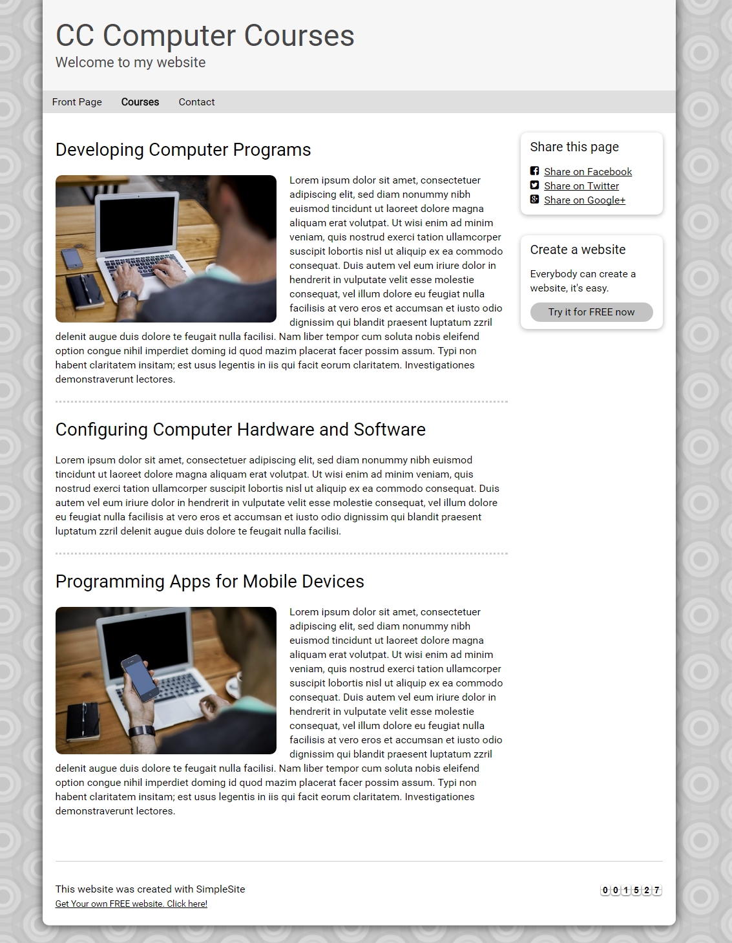

PIC 03 : Display Contact information

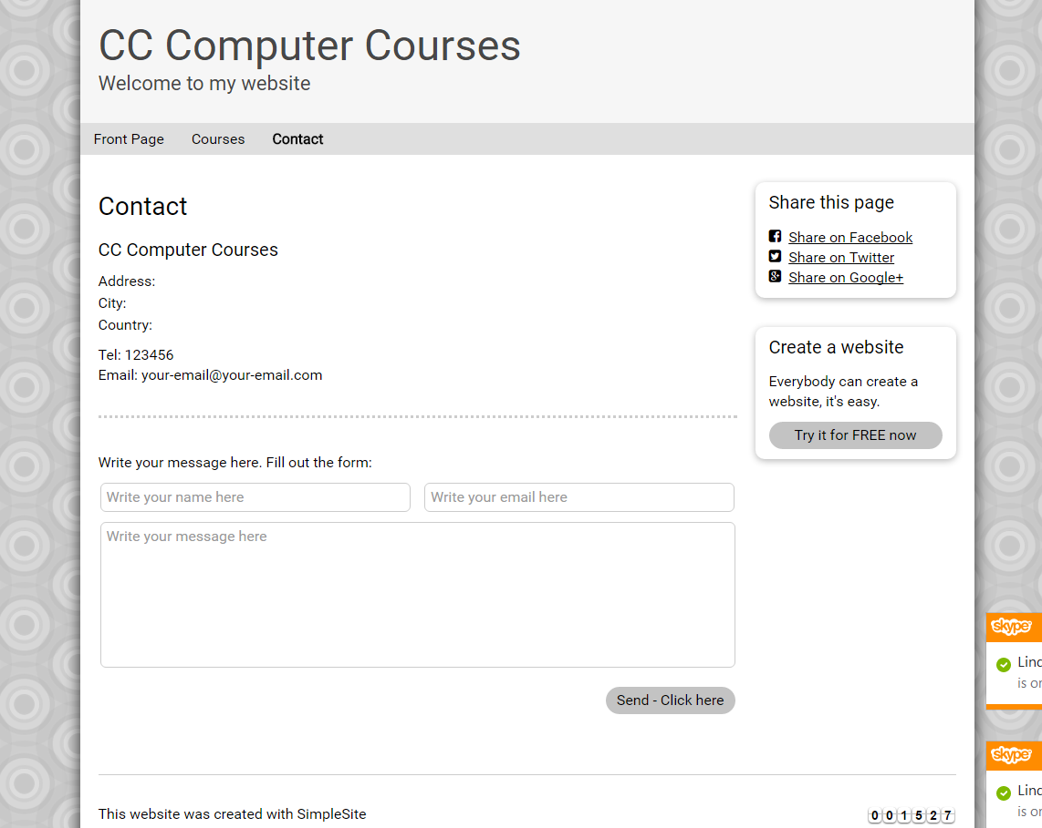

PIC 04 : User send message

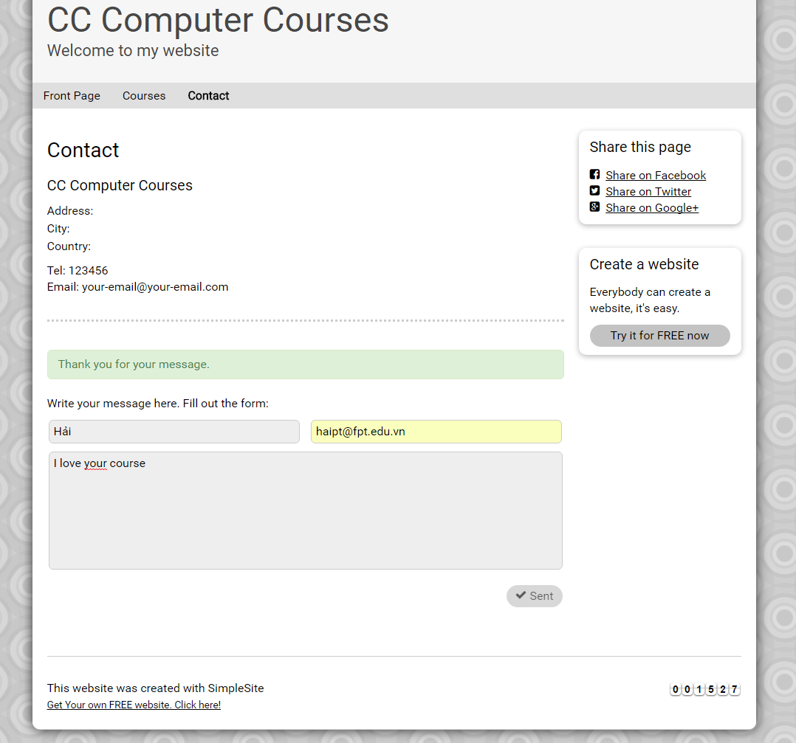

**Guidelines**

* Step 1 : Clarify requirement & scope with mentor
* Step 2 : Create prototype
* Step 3 : Design database base on created prototype
* Step 4 : Code & Test